IN-HOUSE HOTEL MANAGEMENT

SUBJECT: SOFTWARE ENGINEERING

SEMESTER-4 BATCH: D3

DEPARTMENT OF COMPUTER ENGINEERING

FACULTY OF TECHNOLOGY

|  |  |  |
| --- | --- | --- |
| NAME | ROLL NUMBER | ID NUMBER |
| Raychura Utsav | CE116 | 18CEUOS094 |
| Purohit Sanjana | CE118 | 19CEUED006 |

**Project Description**

The system will contain multiple software and multiple interacting users. The system will contain multiple software and multiple interacting users. The guest will arrive at the hotel and check for the room according to his/her requirements. Guest will ask the Receptionist for the availability of room. Receptionist will check the availability of room and if rooms are available then the receptionist shows available rooms to the Guest. If Guest wants that room(s) then receptionist will gather the details of the guest (Like Name, Age, Address, Contact no. etc.). At that time he/she will use Computerized System for the registration of Guest. Record of The Guest will be stored in database. After registering the Guest, Receptionist will ask the guest for date of check-in, check-out, Type of Room, Number of Adults etc. for Booking a Room. Then receptionist will allocate selected room to the Guest. The currently allocated room will be marked as allocated in the software for specific date of registration. Hotel Manager & Receptionist can see the details of Specific Guest. If the Guest has extra amenities (update in current requirement), he/she can contact receptionist. Receptionist will provide those amenities if they can & add extra charges for that in Bill. The Receptionist also has the status of the rooms which are cleaned and which are not. Housekeeping staff will report the receptionist for room status and inventory. Housekeeping staff will maintain the inventory. If anything is needed, they will inform the receptionist. If the Guest want to extend the limit of stay, then guest can tell receptionist and the receptionist will again check the availability. If possible then, he will extend check-out date & according to that, increase the bill amount. Opposite to that, if guest want to reduce check-out date, the receptionist will reduce the date from database and according to that will deduct the money from Bill. While paying the bill, there are different options available for the Guest to pay (i.e. Credit Card, Debit Card, Net Banking, Online Payment via Paytm, Phone Pay etc.). The receptionist will clear the payment and clear the Bill. After payment, Receptionist will take feedback from the Guest. Guest will fill the feedback (not necessary) and can give the suggestions if he/she wants to and also, he/she can rate Hotel Aura. Apart from registering Guest, the system will also do registration and login of staff members. Hotel Admin/Manager, who is head of all the staff members, can see the whole staff list (Like Name, Contact No., Designated Salary and Address of all the staff members). Hotel Manager can also see whether the staff member’s salary is paid or remaining. Moreover, there will be daily attendance for every staff member. After a month, if attendance of any member is less than a particular limit (Say 70%), then salary will be deducted accordingly. The System will generate unique ID for every staff member. Software should be secure and will provide different level of authentication for different users. Software will we web portal and runnable on every computer. Software is user-friendly, easy to understand and has a maintainable database.

**Functional Requirements**

* Register Guest
* Login Guest
* Make Reservations
* Manage Guest (Add, Update, Delete)
* Manage Room (Add, Update, Delete)
* Manage Payment
* Issue Bills
* Feedback
* Register Staff
* Login Staff
* Manage Staff (Add, Update, Delete)

**Nonfunctional Requirements**

* Safety Requirements
* Security Requirements
* Reliability
* Performance Requirements

**Software Requirement Specification**

1. Manage Guest

These operation will be performed by guest or the staff.

* 1. Check if user already exists

Input: User details

Output: Acknowledgement to user

Process: Comparing the given user details with the database

* 1. Create new user account

Input: User details

Output: Acknowledgement to user

Process: Storing the given user details in database

* 1. Update user details

Input: Updated user details

Output: Acknowledgement to user

Process: Updating the user data in database

* 1. Show all user and details

Input: User interaction

Output: List of all users along with details

Process: Fetch details from database

1. Manage Staff

These operation will be performed by staff and admin

2.1 Check if staff already exists

Input: User details

Output: Acknowledgement to user

Process: Comparing the given user details with the database

* 1. Create new staff account

Input: User details

Output: Acknowledgement to user

Process: Storing the given user details in database

* 1. Update staff details

Input: Updated user details

Output: Acknowledgement to user

Process: Updating the user data in database

* 1. List all staff

Input: User interaction

Output: List of all users along with details

Process: Fetch details from database

3.0 Login

To login the system guest, staff and admin will use pre-inserted username and password at the creation of account.

Input: Username and Password

Output: According to type of user dashboard of site will be displayed

Process: Check if user exists and starts the session

1. Manage Booking

These operations will be performed by staff and guest for booking the stay at hotel

4.1 Room booking

Input: Check-in, check-out date and other details

Output: Acknowledgement to user

Process: Reserve the room (update the database)

4.2 Cancel booking

Input: Username and details

Output: Acknowledgement to user

Process: Update database regarding to the room (deletes reservation of rooms)

4.3 Update booking

Input: Necessary details

Output: Acknowledgement to user

Process: Update database

1. Review/ Feedback
   1. Review staff

Description: Manager will review other staff

Input: Performance and other notes

Output: Acknowledgement to user

Process: Submitted to the database

* 1. Guest feedback

Input: Performance and other notes about hospitality at hotel

Output: Acknowledgement to user

Process: Submitted to the database

1. Payment

Input: Valid input like payment type, payment details

Output: Acknowledgement to user, Email or message by the respected bank

Process: Payment process

1. Logout

Input: User interaction

Output: Acknowledgement to user

Process: Ends ongoing session

1. Manage rooms
   1. Add room

Input: Details like type, no etc.

Output: Acknowledgement to user

Process: Adds new room to database

* 1. Delete room

Input: Room no, room id

Output: Acknowledgement to user

Process: Removes room from database

* 1. Reserve room

Input: Reservation details

Output: Acknowledgement message to user

Process: Update room status

* 1. Update room details

Input: Updated details

Output: Acknowledgement message to user

Process: Update database with new details

**Screenshots of project**

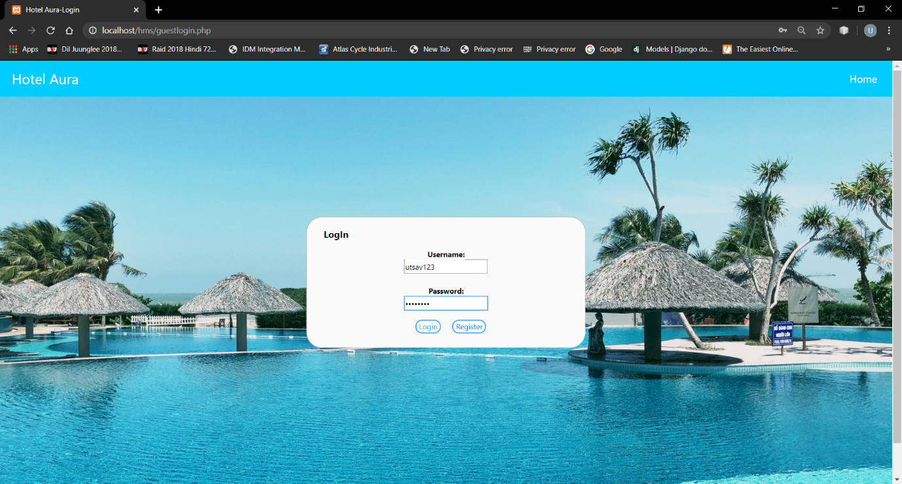

Figure 2 Registration

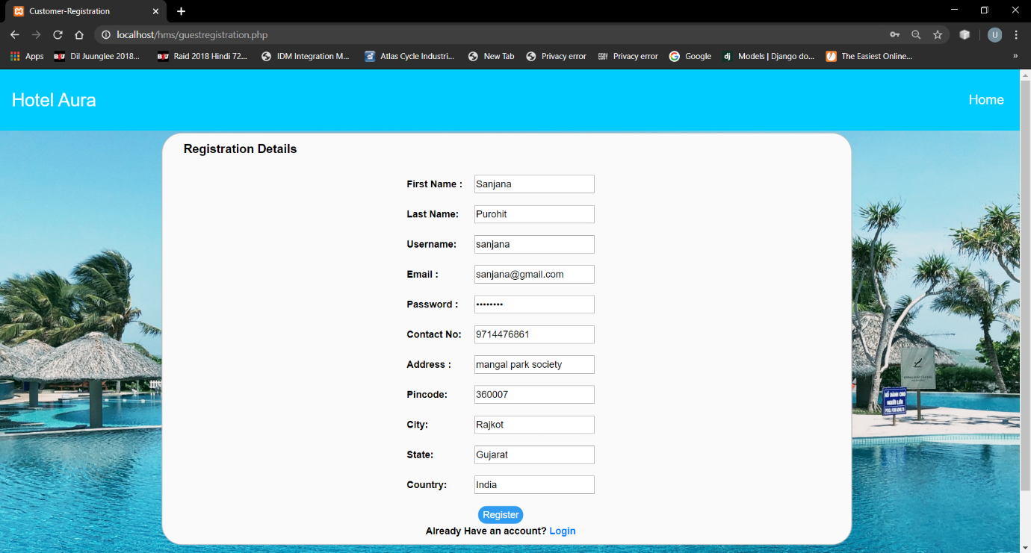

Figure 1 Login

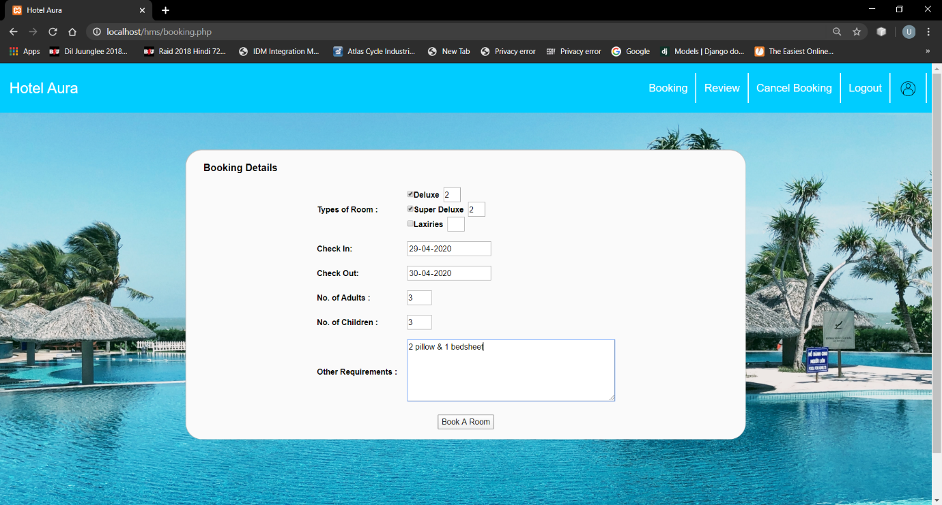

Figure 3 Booking

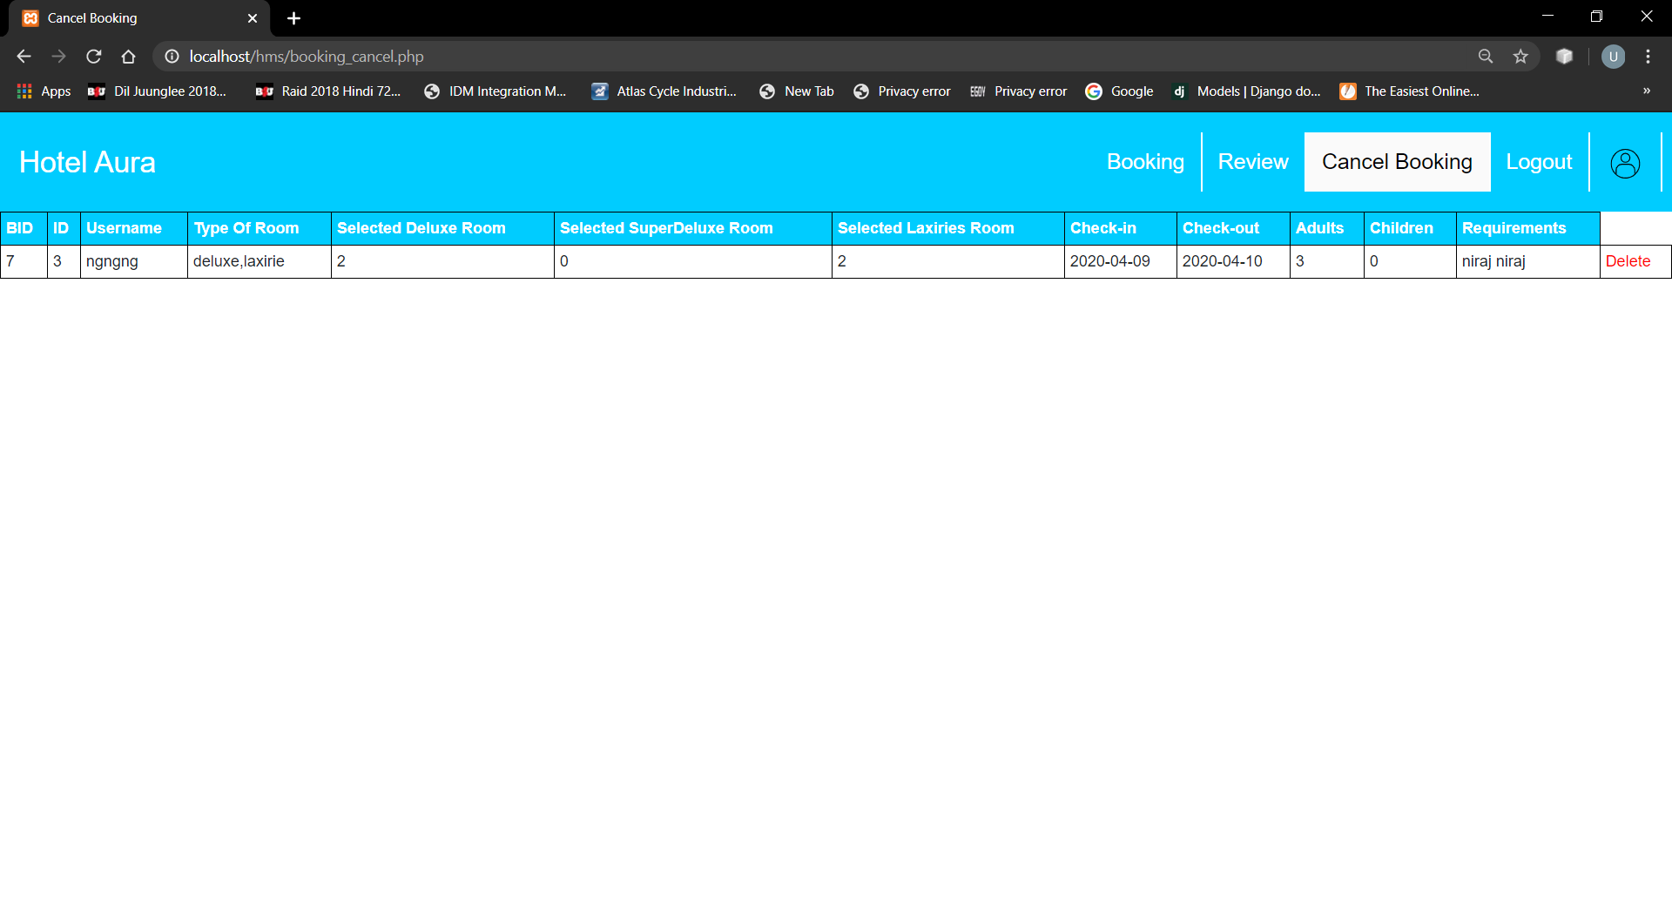

Link of zip file containing source code and readme file –

Figure 4 Cancel Booking

https://drive.google.com/open?id=1H9UuoCLD0tKB5GIvhi1o74FU6cy5mavA

Video Link:

https://drive.google.com/open?id=1kCLXtQ708aY6nklepzlJcfzSn5wItpyl